**Department of Computer Science and Engineering,**

**DAYANANDA SAGAR COLLEGE OF ENGINEERING**

*(An Autonomous Institution affiliated to VTU, Accredited with NAAC ‘A’ Grade)*

**BANGALORE – 560078**

A Mini-Project Report on

**Topology of the CS Department with Email, HTTP and DNS Services**

Submitted in 5th Semester

**Bachelor of Engineering**

In

**Computer Science and Engineering**



Submitted by

##### Abhishek 1DS16CS130

##### Vadiraj K R 1DS16CS131

##### Ruthwik H P 1DS16CS125

##### Under the guidance of

##### Faculty Name Prof. Asnika

##### Designation,

##### Dept. of CSE, DSCE

2018-2019

**Abstract**

Cisco Packet Tracer is a cross-platform visual simulation tool designed by Cisco Systems that allows users to create network topologies and imitate modern computer networks. Network topology is the arrangement of the elements of a communication network. Network topology can be used to define or describe the arrangement of various types of telecommunication networks. Our project will be using the Cisco packet tracer to implement a topology of the CS Department in which email, HTTP and DNS services will be implemented to allow for better understanding of ­­­­­­­­­­­networking concepts.

**Table of Contents**

|  |  |  |
| --- | --- | --- |
| **Number** | **Topic** | **Page Number(s)** |
| 1 | Introduction | 4 |
| 1.1 | Objectives of the Project | 4-5 |
| 2 | Design/Implementation | 5-7 |
| 2.1.1 | Topology of the 3rd Floor | 5-6 |
| 2.1.2 | Topology of the 4th Floor | 6 |
| 2.2 | Implementation | 7 |
| 3 | Testing and Analysis | 8-9 |
| 4 | Snapshots of Results | 9-11 |
| 4.1.1 | Topology | 9 |
| 4.1.2 | Email | 10 |
| 4.1.3 | HTTP (Web) | 11 |
| 5 | Conclusion and Future Enhancement | 12 |
| 5.1 | Conclusion | 12 |
| 5.2 | Future Enhancement | 12 |

1. **Introduction**

Packet Tracer is a cross-platform visual simulation tool designed by Cisco Systems that allows users to create network topologies and imitate modern computer networks. The software allows users to simulate the configuration of Cisco routers and switches using a simulated command line interface. The interface of the packet tracer is that of a drag and drop implementation which allows users to add and remove devices which stimulate an actual network. This software is focused towards Certified Cisco Network Associate Academy (CCNA) students as an educational tool for helping them to learn fundamental concepts. The Cisco packet tracer tool can be used via a guest login but with a fewer privileges compared to a student enrolled in a CCNA academy.

Our project titled “Topology of the CS Department with Email, HTTP and DNS Services” uses the Cisco packet tracer. We are developing a model which shows the topology of the CS department’s labs which contain the systems. This project will highlight features of components used in the Cisco packet tracer.

* 1. **Objectives of the Project**
* Enhancing the concepts used in the Cisco packet tracer.
* Developing the topology of the CS Department using the Cisco packet tracer.
* Configuring the computer systems available in the labs to ping each other, send data, emails and be able to access the internet using DNS.

1. **Design/Implementation**

This project highlights features of components used in the project and Cisco Packet Tracer. This project demonstrates how the computers in the CS department are connected in the network. It is only using the switches in every lab to connect the computers in a network. Topology is designed only for department labs. The total number of switches in the entire department is 9.

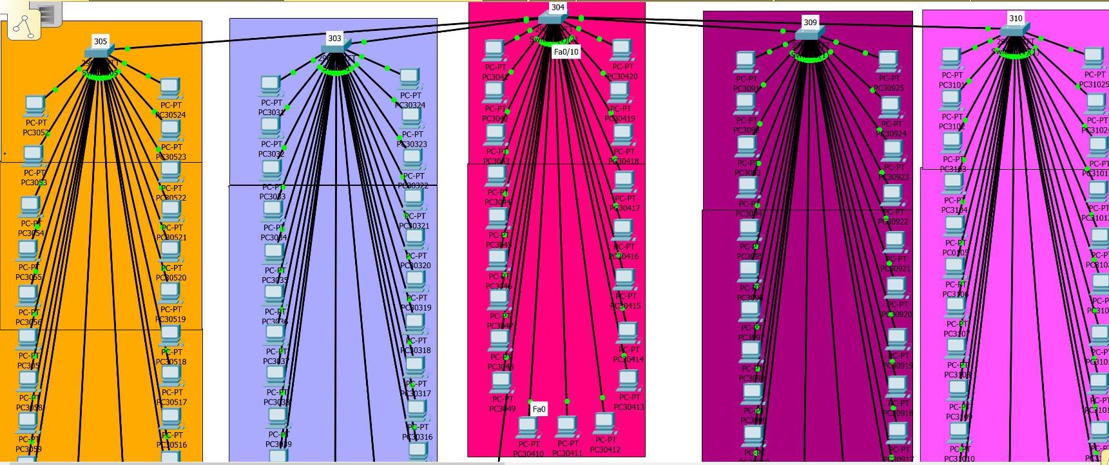**2.1.1 Topology of 3rd Floor**

Here we can see that multiple labels have been allotted and each label (colour) is a lab in the CS department’s 3rd floor.

Total number of computers in 303: 24.

Total number of computers in 304: 20.

Total number of computers in 305: 24.

Total number of computers in 309: 25.

Total number of computers in 310: 25.

303, 304, 305, 309 and 310 all have a single switch.

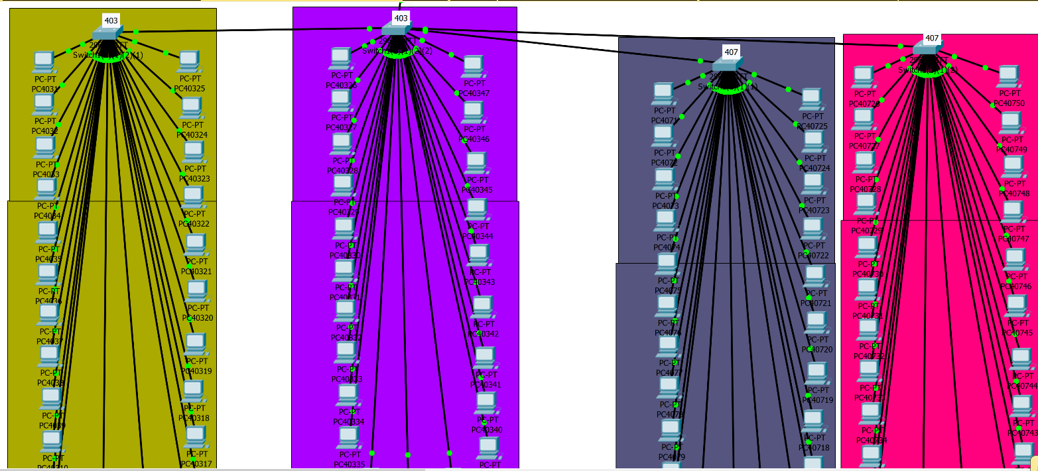**2.1.2 Topology of 4th Floor**

Here we can see that multiple labels have been allotted and each label (colour) is a lab in the CS department’s 4th floor.

Total number of computers in 403: 47.

Total number of computers in 407: 50.

Here, 403 and 407 have two switches each.

**2.2 Implementation**

We have incorporated the following services into the network topology

1) DNS

2) Http

3) Email

The above services can be implemented by adding dedicated servers which are either separate or a multi-server which integrates all these together. We have added them separately, all connected to the main switch which in turn connects the PCs of all the labs. DNS consists of all the domain names of the sites that can be accessed through the lab computers. In our case we have added google and Facebook. Http to load the pages on the web browser. Email is implemented by registering 2 systems with the service provider distinguished by different usernames and passwords. By doing so the systems are able to communicate between each other.

1. **Testing and Analysis**

The topology has been tested successfully, were able to mimic the real topology of the labs in CS dept. It follows a star topology.

We have tested the systems regarding email services and web service. Logging into the internet can be done with ease and the DNS we have implemented helps us access sites like google and Facebook.

In a Class C network, the first two bits are set to 1, and the third bit is set to 0. That makes the first 24 bits of the address the network address and the remainder as the host address. Class C network addresses range from 192.0.0.0 to 223.255.255.0. In our project we have used IP addresses starting from 192.168.3.1 to 192.168.3.214.

The first computer is present on the third floor and the last computer is present on the fourth floor. We have given the server an IP address of 192.168.3.250.

For sending and receiving emails, we have used the HTTP protocol. To send emails, we have assigned a username and a password to each individual computer according to the domain name that we have given. We have used yahoo.com as our domain name.

To send emails, we first register the computer to the list of users in the email user database by giving it an appropriate username and password. Then we can send emails as well as receive emails from different computers. The only requirement is that, the computer which is sending or receiving emails must be registered in the list containing all the users.

1. **Snapshots of the Results**

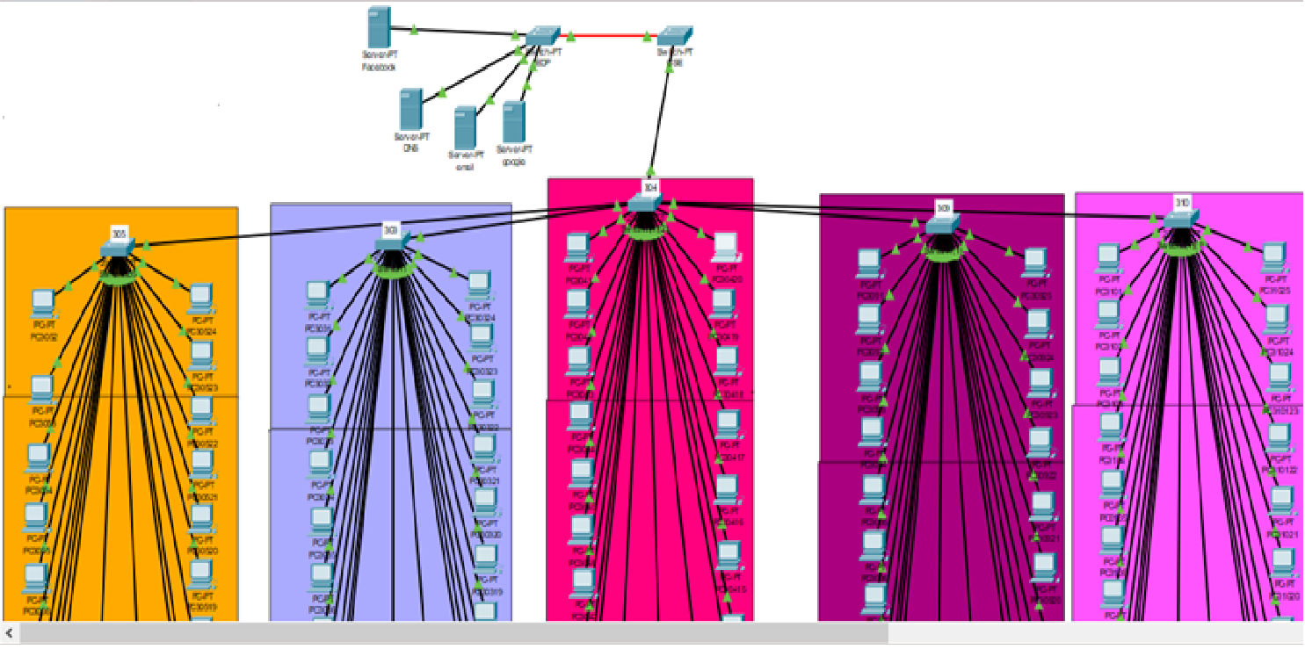**4.1.1 Topology -**

Here we have connected 4 servers to the EDP switch. Google, Facebook, Email and DNS. The 4 servers are connected to the EDP switch and that is connected to the CS switch. The CS switch is hence connected to each of the switches in the network.

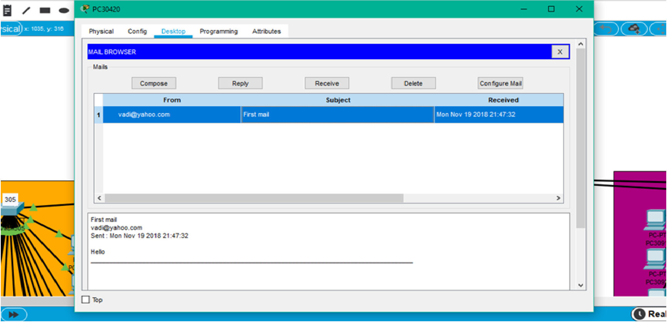**4.1.2 Email -**

Here we see an example of the Email service. Here we compose an email with the sender’s address, the subject of the mail and the message itself. Above we see the receiver side of the email. By clicking on the receive button, the mail will be received from the sender.

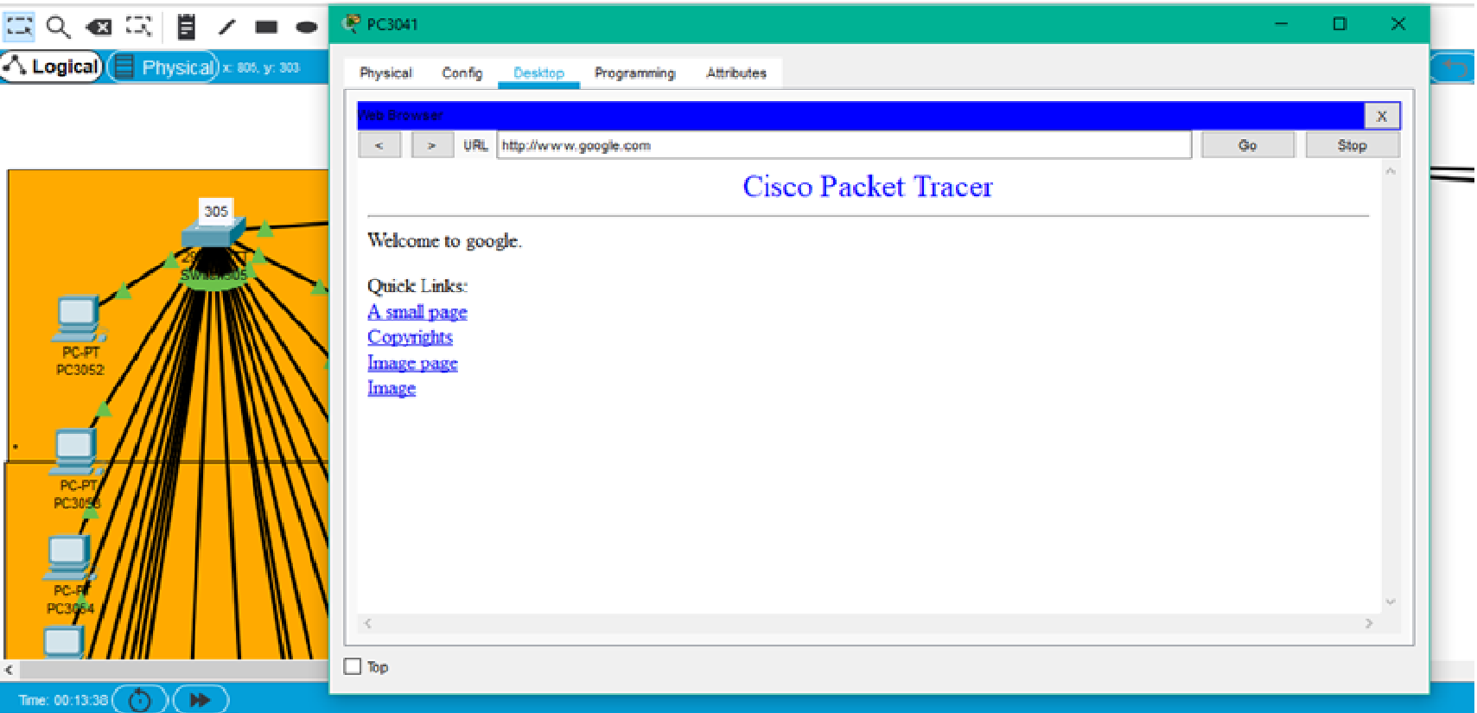**4.1.3 HTTP (Web) -**

Here we can see an example of the DNS server being used. The site “www.google.com” has been added as a separate server in the network whose IP address has been added in to the DNS server. The node that needs to access the site must have the same DNS server IP. After that, a simple search in the web browser will allow the node to access the site.

1. **Conclusion and Future Enhancement**

**5.1 Conclusion:**

In conclusion, we have seen that, by using the Cisco packet tracer, we have replicated the topology that is currently present in the CS department’s labs. We have seen how we can ping the various computers. We can also see that we were able to send packets of data from one computer to another. We have also seen how an email can be sent from one to another computer present in the network. The DNS service as well.

**5.2 Future Enhancement:**

As nothing is completely finished, this project can be further developed. For the moment, we have used the standard protocols for the services that the topology does. We have also been using standard cables to connect the computer systems in the network to each other.

The project can be enhanced by improving the speed of the connections by using different types of cables such as fiber optics for faster internet connections, stronger and faster buses to allow for faster data transfer to occur. We can even implement different protocols to obtain faster and better communication and to send and receive packets of data and emails.